**Lab assignment 6.**

Q.1 Create a database cluster named order_customer and include the tables customer and orders within it.

**Output:**

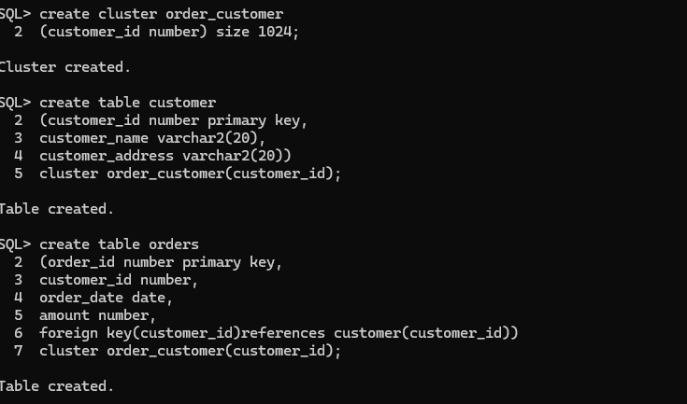

Q.2 Create a snapshot based upon the product_master table.

**Output:**

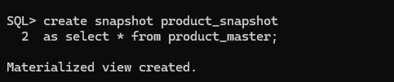

Q.3 Create synonyms pvt_client (private) and pub_client(public) based upon the

client_master table

**Output:**

